Use SQL queries to extract and analyse data from a database.
SCREENSHOTS
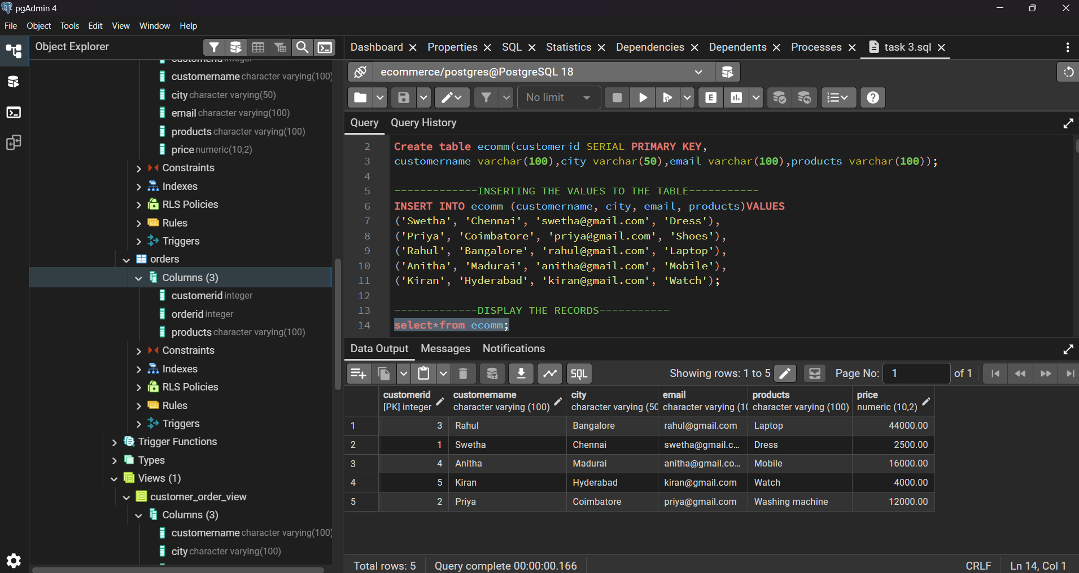
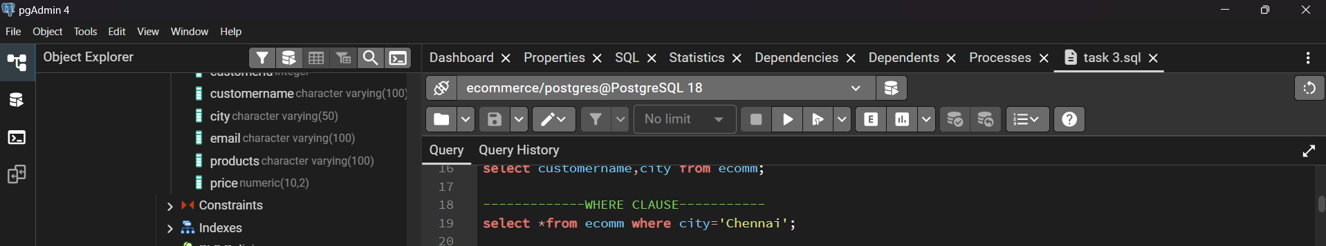
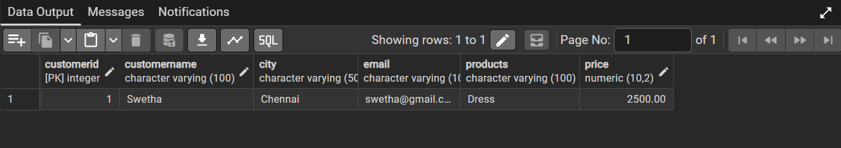

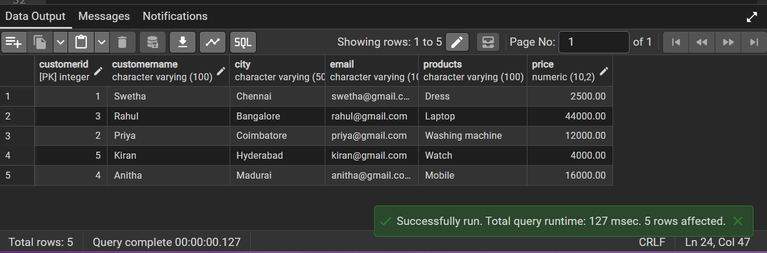

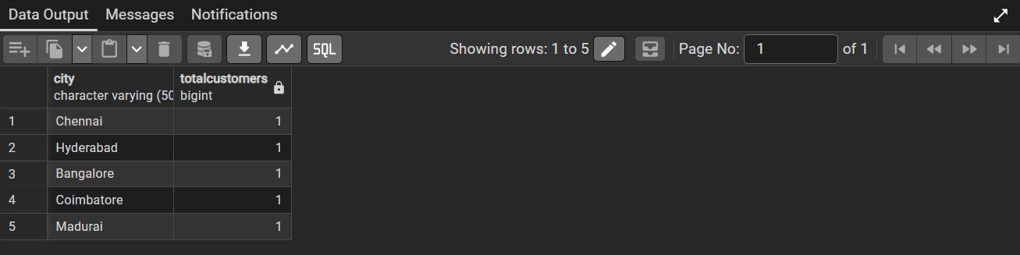
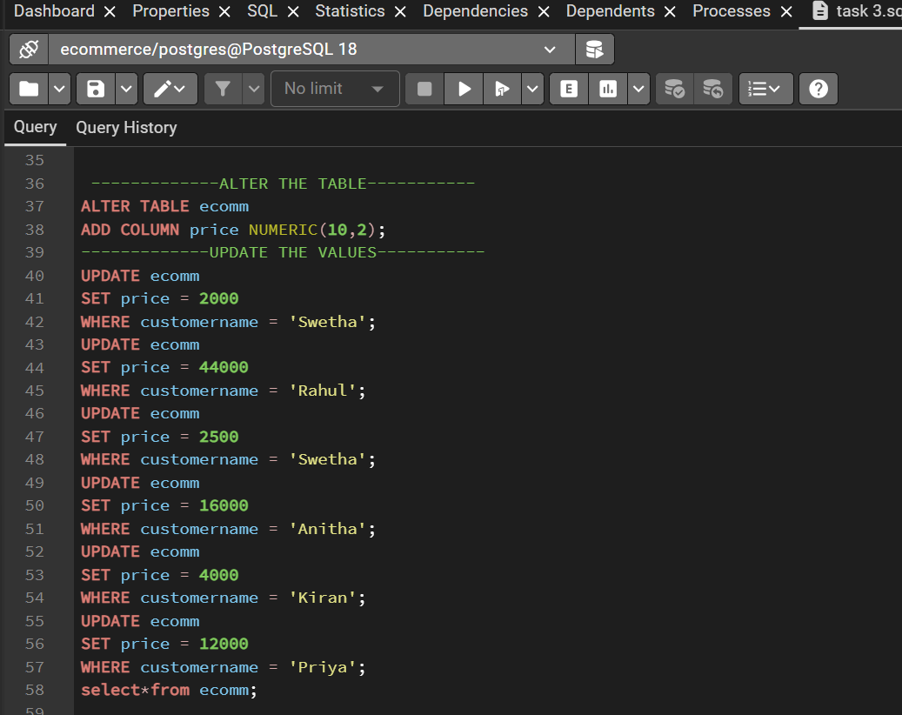
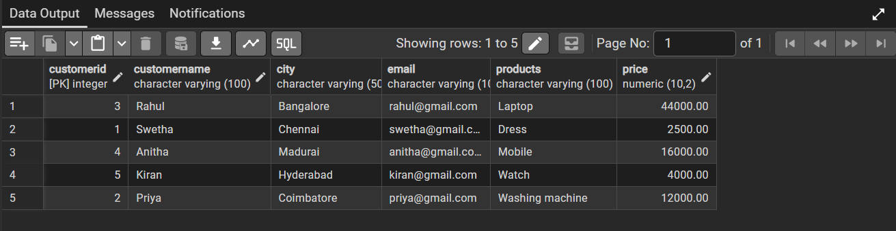
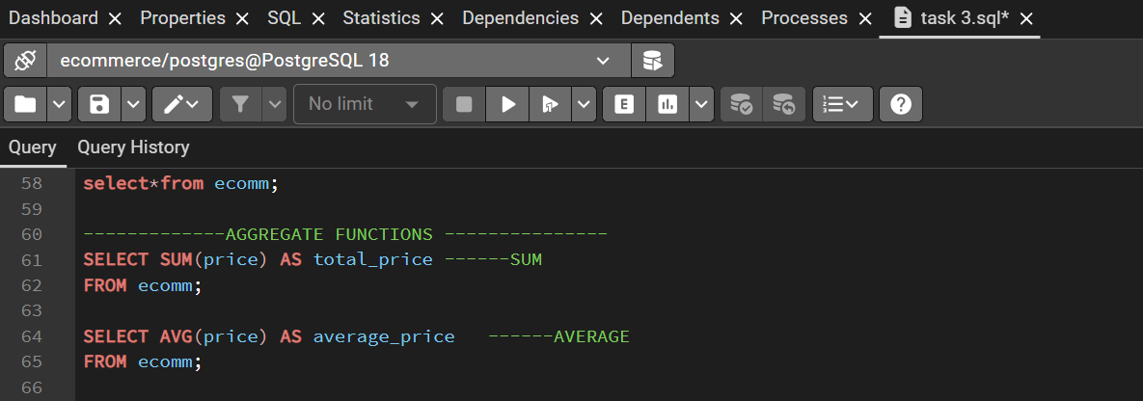
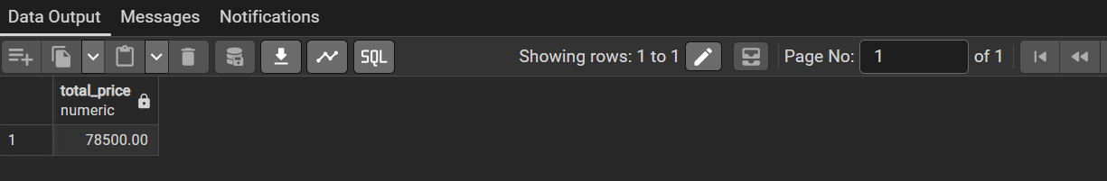
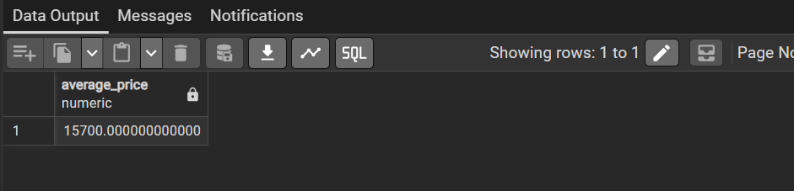
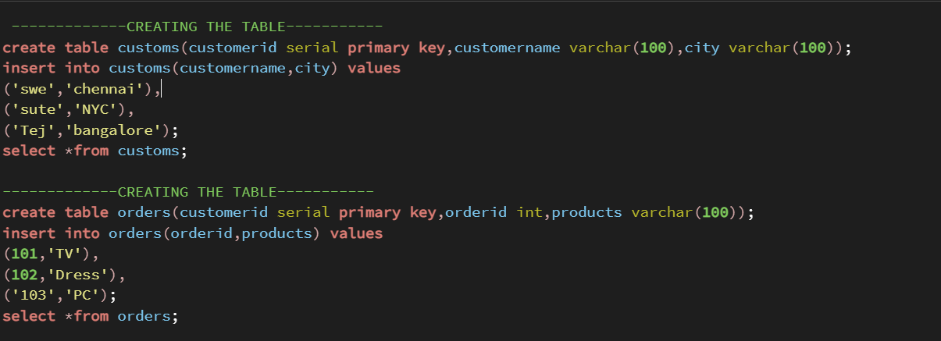
INNER JOIN:
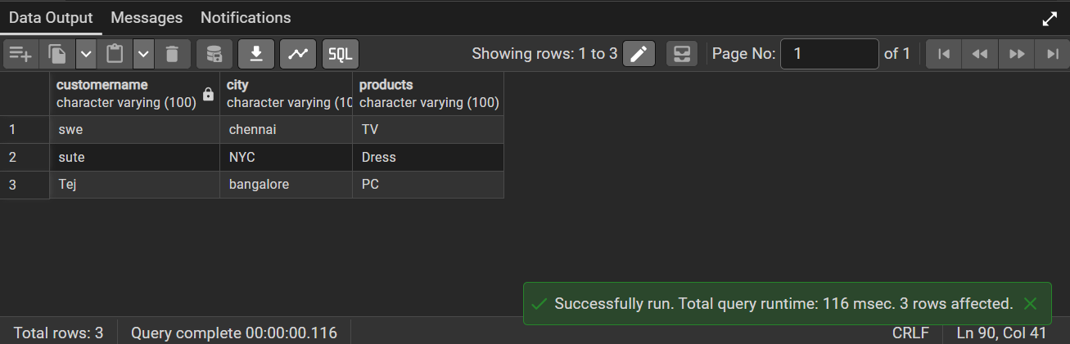
LEFT JOIN:

RIGHT JOIN:

SUB QUERIES:
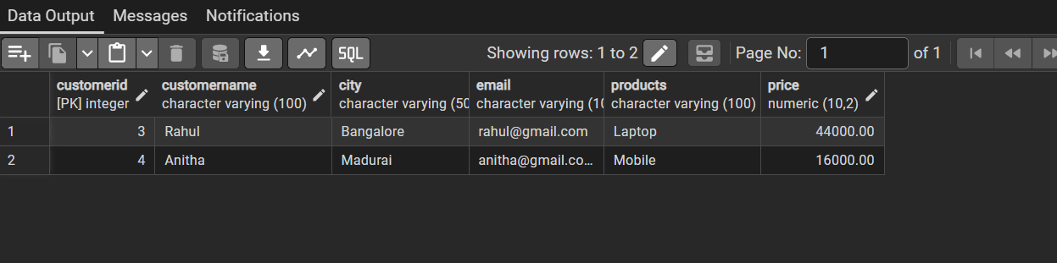
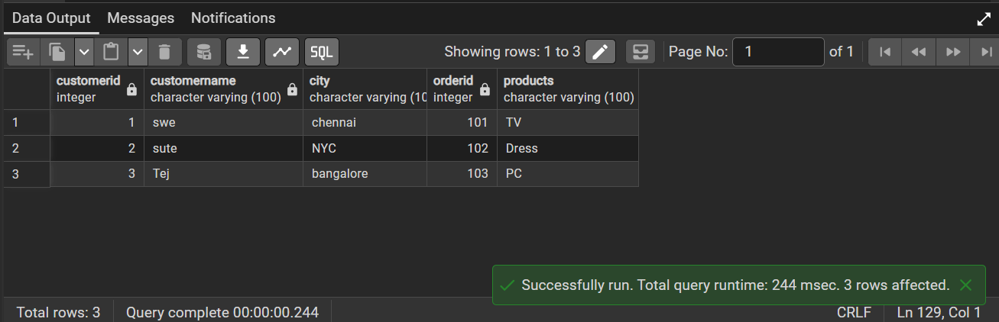
INDEX:
